DISHES AND THEIR ALLERGEN CONTENT
(Note – Please state the name of the cereal(s) containing gluten** in that column AND/OR the name of the nut(s)* in that column)

DISHES | 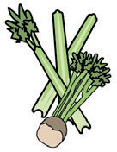 | 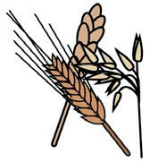 | 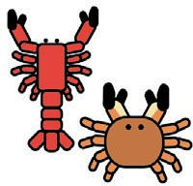 |  |  | 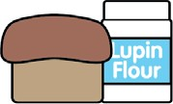 | 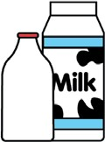 |  | 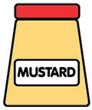 |  | 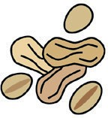 | 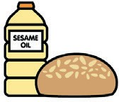
 | Celery | Cereals containing gluten** | Crustaceans | Eggs | Fish | Lupin | Milk | Molluscs | Mustard | Nuts* | Peanuts | Sesame seeds | Soya | Sulphur dioxide
Tuna Salad [example] | T |  |  | T | T |  | T |  | T
Chips
Sweet potato fries
Lagg fries
Poutine |  | Barley & wheat
Gunpowder fries
Mackerel pate |  | (Bread – gf available)
Mushroom pate |  | (Bread – gf available)
Lamb pastilla |  |  |  |  |  |  |  |  |  | Pistachios
Jalapeno poppers |  | Wheat

DISHES AND THEIR ALLERGEN CONTENT
(Note – Please state the name of the cereal(s) containing gluten** in that column AND/OR the name of the nut(s)* in that column)

DISHES
 | Celery | Cereals containing gluten** | Crustaceans | Eggs | Fish | Lupin | Milk | Molluscs | Mustard | Nuts* | Peanuts | Sesame seeds | Soya | Sulphur dioxide
Tuna Salad [example] | T |  |  | T | T |  | T |  | T
Plain omelette
Cheese omelette
Ham omelette |  |  |  |  |  |  |  |  | In house ham
Cheese and ham omelette |  |  |  |  |  |  |  |  | In house ham
Lentil and veg soup |  | (Bread – gf available)
Cullen skink |  | (Bread – gf available)
Nachos |  | Tortillas – gf available
Nachos supreme |  | Tortillas – gf available

Review date: 22.09.21 Reviewed by: Mike Dixon & Stuart MacPherson
You can find this template, including more information at www.food.gov.uk/allergy
DISHES AND THEIR ALLERGEN CONTENT – KILMORY CAFÉ 2021
(Note – Please state the name of the cereal(s) containing gluten** in that column AND/OR the name of the nut(s)* in that column)

DISHES
 | Celery | Cereals containing gluten** | Crustaceans | Eggs | Fish | Lupin | Milk | Molluscs | Mustard | Nuts* | Peanuts | Sesame seeds | Soya | Sulphur dioxide
Tuna Salad [example] | T |  |  | T | T |  | T |  | T
Cheese & ham SW |  | Wheat  (Bread – gf avail) |  |  |  |  |  |  | In house ham
Cheese & pickle SW |  | Wheat & barley  (Bread – gf avail)
Tuna crunch SW |  | Wheat  (Bread – gf avail)
Egg mayo SW |  | Wheat  (Bread – gf avail)
Carrot & hummus SW |  | Wheat  (Bread – gf avail)
Cheese & ham toastie |  | Wheat  (Bread – gf avail) |  |  |  |  |  |  | In house ham
Cheese & onion toastie |  | Wheat  (Bread – gf avail)
Tuna melt toastie |  | Wheat  (Bread – gf avail)
Cheese toastie |  | Wheat

Review date: 23.09.21 Reviewed by: Mike Dixon & Stuart MacPherson
DISHES AND THEIR ALLERGEN CONTENT
(Note – Please state the name of the cereal(s) containing gluten** in that column AND/OR the name of the nut(s)* in that column)

DISHES
 | Celery | Cereals containing gluten** | Crustaceans | Eggs | Fish | Lupin | Milk | Molluscs | Mustard | Nuts* | Peanuts | Sesame seeds | Soya | Sulphur dioxide
Tuna Salad [example] | T |  |  | T | T |  | T |  | T
Ham Salad SW |  | Wheat – (bread gf available) |  |  |  |  |  |  | In house ham
Ham & pickle SW |  | Wheat & barley – (bread gf available) |  |  |  |  |  |  | In house ham
Fish finger SW |  | Wheat
Tandoori chicken wrap |  | Wheat
Aubergine Milanese |  | Wheat
Plain pup hotdog |  | Wheat
Korean hotdog |  | Wheat
Zen-dog hotdog
French onion hotdog

DISHES AND THEIR ALLERGEN CONTENT
(Note – Please state the name of the cereal(s) containing gluten** in that column AND/OR the name of the nut(s)* in that column)

DISHES
 | Celery | Cereals containing gluten** | Crustaceans | Eggs | Fish | Lupin | Milk | Molluscs | Mustard | Nuts* | Peanuts | Sesame seeds | Soya | Sulphur dioxide
Tuna Salad [example] | T |  |  | T | T |  | T |  | T
Berliner hotdog
Fish cake
Fennel tagliatelle |  |  |  |  |  |  |  |  |  | Pine-nuts
Brown bread
White bread
Gluten free bread
Curdito
Tortilla crisps

Review date:12.10.21 Reviewed by: Mike Dixon & Stuart McPherson
You can find this template, including more information at www.food.gov.uk/allergy

