DISHES AND THEIR ALLERGEN CONTENT – LAGG DISTILLERY BAKERY 2021
(Note – Please state the name of the cereal(s) containing gluten** in that column AND/OR the name of the nut(s)* in that column)

DISHES |  |  | 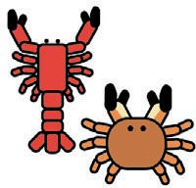 |  |  |  |  |  | 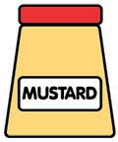 |  |  | 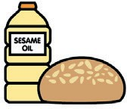
 | Celery | Cereals containing gluten** | Crustaceans | Eggs | Fish | Lupin | Milk | Molluscs | Mustard | Nuts* | Peanuts | Sesame seeds | Soya | Sulphur dioxide
Tuna Salad [example] | T |  |  | T | T |  | T |  | T
Plain / Fruit Scone |  | Wheat
Frangipane |  | Wheat |  |  |  |  |  |  |  | Almonds
Millionaire’s Shortbread |  | Wheat
Chocolate Brownie
Chocolate Fudge Cake |  | Wheat
Citrus Cake |  |  |  |  |  |  |  |  |  | Almonds
Carrot Cake |  |  |  |  |  |  |  |  |  | Hazelnuts
Yoghurt Flapjack
Victoria Sponge |  | Wheat

Review date: 14.10.21 Reviewed by: Mike Dixon

DISHES AND THEIR ALLERGEN CONTENT
(Note –Please state the name of the cereal(s) containing gluten** in that column AND/OR the name of the nut(s)* in that column)

DISHES
 | Celery | Cereals containing gluten** | Crustaceans | Eggs | Fish | Lupin | Milk | Molluscs | Mustard | Nuts* | Peanuts | Sesame seeds | Soya | Sulphur dioxide
Tuna Salad [example] | T |  |  | T | T |  | T |  | T
Cherry Shortbread |  | Wheat

Review date: 14.10.21 Reviewed by: Mike Dixon
You can find this template, including more information at www.food.gov.uk/allergy

